**General Physics Laboratorium**

Ex #44

Topic: THE MEASUREMENT OF THE DEPENDENCE OF RESISTANCE OF METALS ON TEMPERATURE

|  |  |
| --- | --- |
|  |  |
| Name, Surname | Nykonchuk Illia, 245693, W08 |
| Time of classes: | Tuesday, 17:05-18:45 |
| Number of group : | Z00-33d |
| Date of submit: | 30.04.2020 |
| **Grade:** |  |

Approving the measurement results.

Date and signature of the lecturer............................................................

Introduction

In terms of electrical properties solid states can be divided into three groups: conductors, semiconductors and insulators. What makes them different is the concentration of so-called free electrons which are the carriers of charge. Free electrons are not bound to the particular atoms but can move across the crystal lattice. We say about these electrons that they occupy states in a conduction band. The more these atoms and molecules bounce around, the harder it is for the electrons to get by. Thus, resistance generally increases with temperature.

Goal

The measurement of resistance of metal as a function of temperature and calculation of the temperature coefficient of resistance of metal.

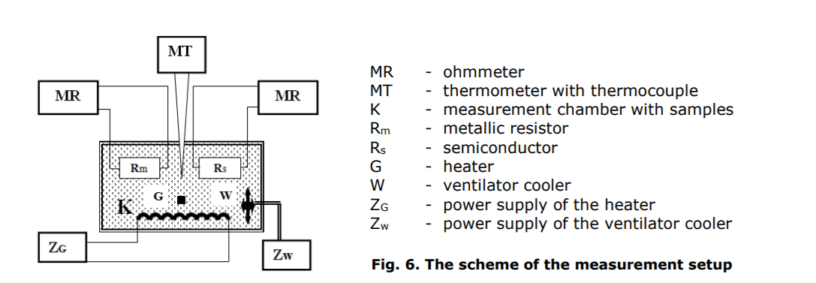Scheme of a measurement setup

Measurement Values

|  |  |  |  |  |  |  |  |
| --- | --- | --- | --- | --- | --- | --- | --- |
| № | t [°C] | u(t) [°C] | R [Ω] | u(R) [Ω] | a [Ω/°C] | b[Ω] | α [°C-1] |
| 1 | 25.2 | 0.5 | 110.6 | 5.7 | 0.3289 | 102.03 | 0.0033 |
| 2 | 29.5 | 112.0 | 5.8 |
| 3 | 34.9 | 113.6 | 5.8 |
| 4 | 39.5 | 115.1 | 5.9 |
| 5 | 45.3 | 116.9 | 6.0 |
| 6 | 50.4 | 118.5 | 6.1 |
| 7 | 55.4 | 119.8 | 6.1 |
| 8 | 60.2 | 121.4 | 6.2 |
| 9 | 64.9 | 123.4 | 6.3 |
| 10 | 69.5 | 124.8 | 6.4 |
| 11 | 74.7 | 126.4 | 6.5 |
| 12 | 80.0 | 128.2 | 6.6 |
| 13 | 84.7 | 130.3 | 6.7 |
| 14 | 90.2 | 131.7 | 6.7 |
| 15 | 95.0 | 133.2 | 6.8 |
| 16 | 100.2 | 134.9 | 6.9 |
| 17 | 104.7 | 136.7 | 7.0 |
| 18 | 110.3 | 138.5 | 7.1 |
| u(x) |  | | | | 0.0022 | 0.16 |  |
| uc(x) |  | | | |  |  | 0.000023 |

Where α - temperature coefficient of resistivity. a and b – coefficients of linear regression

Formulas:

Uncertainties:

u(t)=0,50C

u(R)= 0,5% rdg + 1 dgt

U(R1) =+-(0.5%*110.6+0.1) = +-5.63 Ω

Analysis of the data

Linear regression: y = 0.3289x+102.03

Where y = Rm(t), x=t, 𝑎 = 𝑅𝑜 ∙ α, b= 𝑅𝑜

u(A) = 0.002163 Ω/°C = 0.0022 Ω/°C

u(b) = 0.156402 Ω = 0.16 Ω

α = a/R0  = a/b = 0.00322356169 = 0.0033 °C -1

u(α) = °C -1

Conclusion

Based on the measured data and plotted graph of the resistance of metal as a function of temperature we can conclude that electrical resistance of metals increases with an increase in temperature. At elevated temperatures, the temperature dependence of electrical resistance is generally linear. By linear regression (y = 0.3289x + 102.03) we can find the coefficient of temperature coefficient of resistance of metal (0.0033 C-1). By temperature coefficient of resistance table (<https://workforce.libretexts.org/@api/deki/files/1867/ggg.PNG?revision=1>) we can define that the data obtained from calculations and analysis are seemed to be real.